Play Ball! – Or Not….
Whether the Weather will compel you to call the Game Off

Part 1
June 23, 2015
The Chatsworth Little League championship game is scheduled for a 6:00 PM first pitch. There is pressure to get the game in as the school year is ending and summer vacations are starting for many team members. The weather forecast has south Jersey in a zone where severe weather may occur during the late afternoon or evening. (see Figure 2)

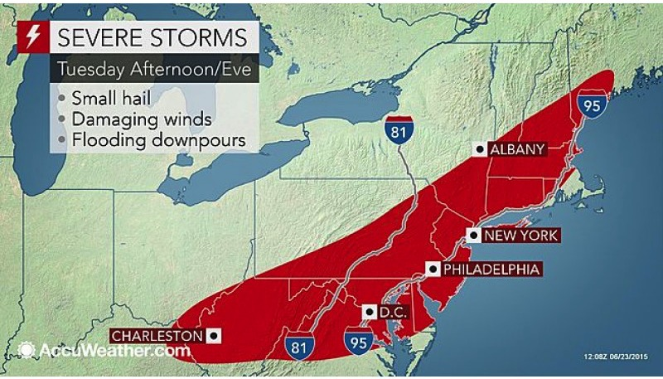
Figure 1: Accuweather forecast outlook issued at 8:00 AM June 23, 2015

The National Weather Service Philadelphia office issued the following forecast at 12:30 PM that day:
Forecast
SOUTHEASTERN BURLINGTON-
INCLUDING THE CITIES OF...WHARTON STATE FOREST
1230 PM EDT TUE JUN 23 2015

...SEVERE THUNDERSTORM IN EFFECT UNTIL 7 PM EDT THIS EVENING...

.THIS AFTERNOON...SHOWERS AND THUNDERSTORMS LIKELY. SOME THUNDERSTORMS MAY BE SEVERE WITH DAMAGING WINDS. BREEZY...HOT WITH HIGHS IN THE MID 90S. SOUTHWEST WINDS 15 TO 20 MPH WITH GUSTS UP TO 30 MPH. CHANCE OF RAIN 70 PERCENT.

Questions:
1. Referring to Figure 1, what weather can be expected at the time of the game in Chatsworth, NJ?

2. Referring to the forecast from the National Weather Service, has the forecast changed from 8AM? ________ Explain with evidence.

3. What is your decision on whether or not to play the game as scheduled? ___________ Explain with evidence.

Part 2

The time is now 4:30 PM. The morning severe outlook only gives you initial information that there will be a need for further evaluation or assessment several hours before the game starts. Here is the dilemma:
- Make a late afternoon decision to postpone the game?
- Start the game and keep an eye on the weather?
- Start the game early and get it in before a storm arrives?
- Pay no attention to the forecast?

Here is your 4:15 PM National Weather Service forecast:
Forecast
SOUTHEASTERN BURLINGTON-
INCLUDING THE CITIES OF...WHARTON STATE FOREST
415 PM EDT TUE JUN 23 2015

...SEVERE THUNDERSTORM IN EFFECT UNTIL 11 PM EDT THIS EVENING...

.TONIGHT...MOSTLY CLOUDY WITH SHOWERS AND THUNDERSTORMS LIKELY THIS EVENING...THEN PARTLY CLOUDY AFTER MIDNIGHT. SOME THUNDERSTORMS MAY BE SEVERE WITH DAMAGING WINDS. LOWS IN THE UPPER 60S. NORTHWEST WINDS 5 TO 10 MPH...BECOMING NORTH AFTER MIDNIGHT. CHANCE OF RAIN 60 PERCENT.

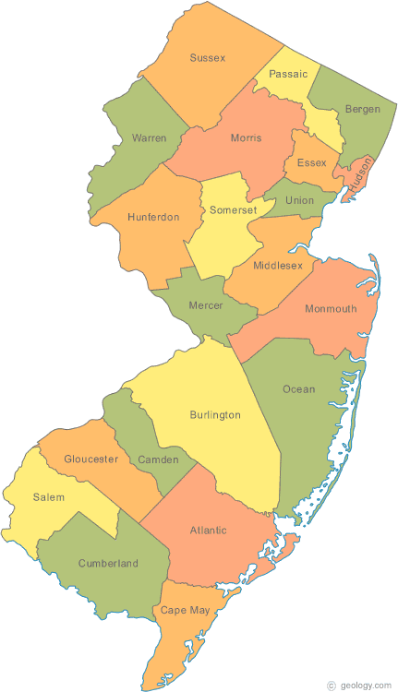
Hammonton

Sewell
Chatsworth-Oswego Lake
Figure 2: Locations mentioned in this case study

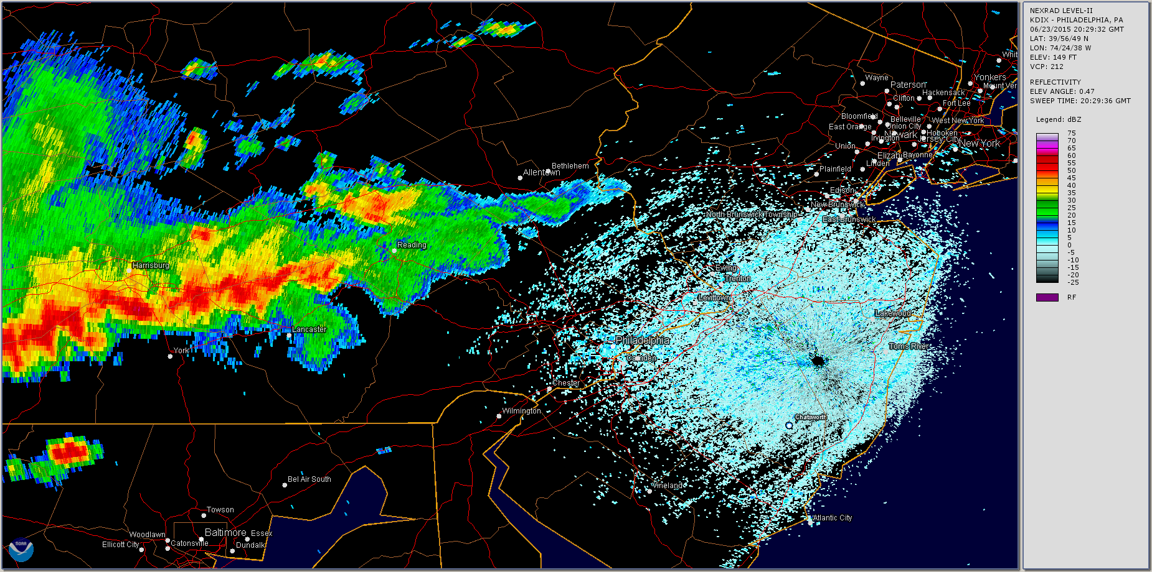

Figure 3: National Weather Service radar image for 4:30 PM, June 23, 2015
Here is the weather data from the NJ WeatherNet for the 3 locations identified in Figure 2. Note that Oswego Lake is located near Chatsworth, NJ.

Figure 4: Weather Data for Sewell, NJ

Figure 5: Weather data for Hammonton, NJ

Figure 6: Weather Data for Oswego Lake, NJ (near Chatsworth)

Questions:
1. Look at the latest forecast and radar (Figure 3). Has the forecast changed for this region since the morning forecast? ______ Explain with evidence from the forecast and radar.

2. Figures 4-6 consists of the data from the day of the storm. At this point in the scenario, you only have access to the data up to 4:30 PM at each station. What time is that on the charts? _______________

Assess the data from a spatial viewpoint using the map in Figure 2 for assistance. Is there much of a difference across this region? _________ Explain with evidence.

3. Now let's consider the dilemma.
- Make a late afternoon decision to postpone the game?
- Start the game and keep an eye on the weather?
- Start the game early and get it in before a storm arrives?
- Pay no attention to the forecast?

What is your decision?__________________________________________________________________ Explain your reasoning from the evidence available to you up to 4:30 PM only!

Part 3

It is now 6:00 PM and the decision was to play the game while keeping an eye on the storm by using hand-held devices with access to http://njweather.org while at the game, and by having someone keep an eye on the western sky. Your new data includes the data after 4:30 PM found in Figures 4-6 in Part II, and the National Weather Service radar images below.

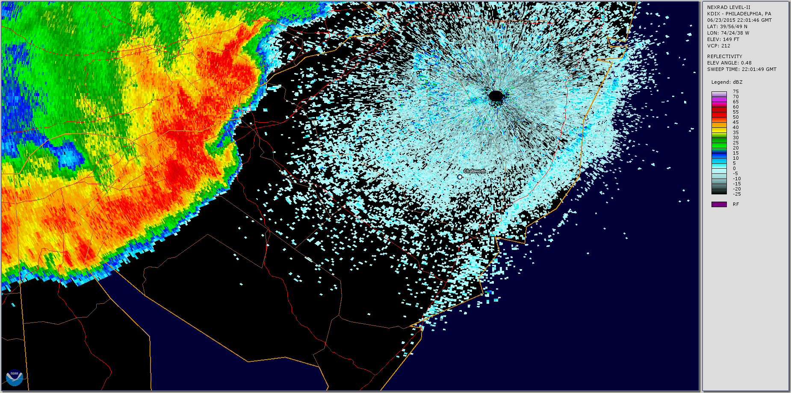

Figure 7: National Weather Service radar image for 6:00 PM, June 23, 2015

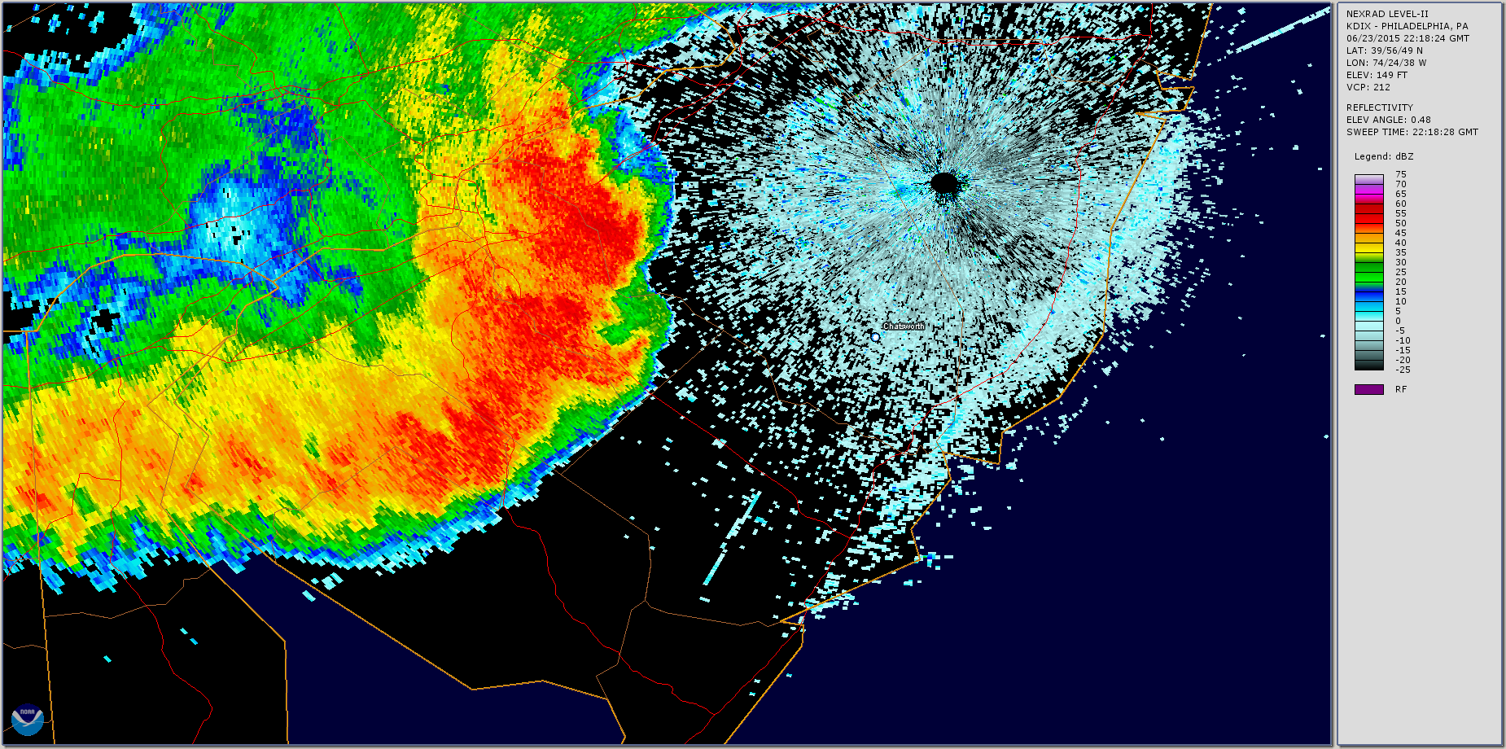

Figure 8: National Weather Service radar image for 6:18 PM, June 23, 2015

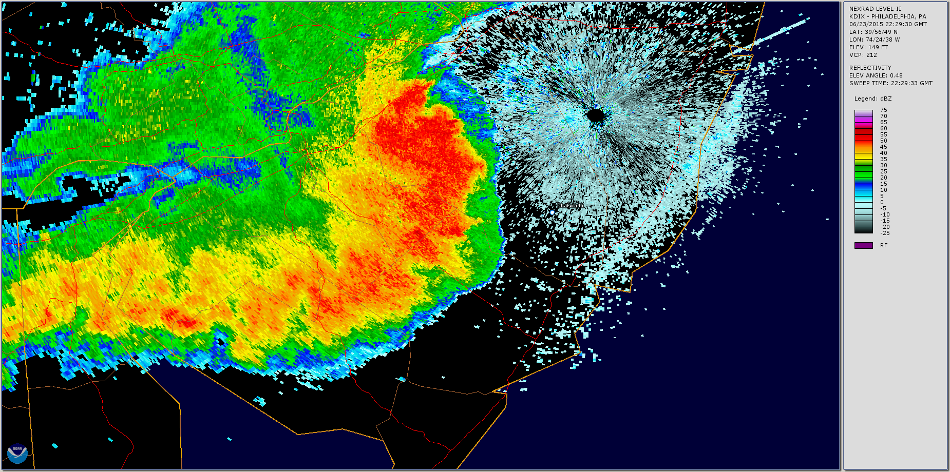

Figure 9: National Weather Service radar image for 6:30 PM, June 23, 2015

Questions:
1. Using the data in Figures 4-6 from 4:30 PM to 6:30 PM, complete the table below describing the changes observed in each of the parameters at each location. Remember, to support your descriptions with evidence from the data!

Location | Temperature & Dew Point | Wind Speed & Wind Direction
Sewell
Hammonton
Oswego Lake/
Chatsworth

2. Now, analyze the radar data in Figures 7-9. Approximately how fast is the storm moving? ______________ How did you arrive at this answer?

3. What should the umpires and coaches do at this point?

Part 4

Here are the data from the event.

Figure 10: Precipitation data from the 3 locations

Figure 11: Temperature data from the 3 locations

Figure 12: Wind gusts from the 3 locations

Final Task:

You are a National Weather Service Forecaster who documented this event and have now been tasked with creating a summary report about it. Use all of the data provided to you (including but not limited to Figures 10-12) to create a 3+ paragraph summary of the storm that includes numerous references to the data presented throughout the case. You will be assessed on how well you can tell the scientific story of this event.

